# Winning SuperCoach with Half the Budget

*Steven Edwards is a PhD Candidate in the School of Mathematics at Monash University who works on large-scale optimisation problems.*

## A minimalist’s guide to team selection.

As we prepare for the start of SuperCoach 2019 with the season opener between Carlton and Richmond this Thursday, many coaches are putting the finishing touches on their teams. For the majority of these coaches however, the starting budget of $10m will be far too little to afford all the players they want.

But perhaps amidst all the chaos of preseason fantasy football we have forgotten to stop and realise that $10m is actually quite a lot of money. Imagine the good we could do in the world if this SuperCoach season, instead of spending our entire budgets on fancy players, we spent only what we needed and then gave the rest away. Imagine that positive karma. Powerful.

Last year, the [Optimal Team](https://www.heraldsun.com.au/sport/afl/supercoach-news/the-optimal-supercoach-2018-team-would-have-scored-11000-more-points-than-the-overall-winner/news-story/7114f1a9d11643a9abfb774ae9ae174f) obtained a score of 62,208 completely obliterating [Cole Cook’s winning score](https://www.heraldsun.com.au/sport/afl/supercoach-news/cole-cook-credits-some-timely-trading-and-a-keeping-trades-up-his-sleeve-for-winning-50000/news-story/46d013b05d6a601f63f55719beacc0be) of 53,852. In fact, a [Ghost Team](https://www.heraldsun.com.au/sport/afl/supercoach-news/the-supercoach-ghost-team-that-would-have-finished-in-top-100-without-a-single-trade/news-story/5bda3054014637b52894a88e1ce5c249) that was set up at the start of the year and then completely abandoned could have come 77th.

To understand the amount of budget that we could potentially live without, let’s once again revisit 2018 and see what we can learn.

## Introducing the 2018 SuperCoach Budget Team of the Year

In 2018, the cheapest starting budget from which it was still possible to select a side and win the competition was $5,137,200. This equates to just over half of the excessive $10m budget. The team finishes with a total of 53,866 points, pipping Cole Cook by just 14 points.

Admittedly you would need a lot to go right to pull this off. In fact you would need absolutely everything to go right. But remember you would have karma and the universe on your side.

## Starting Team

The starting team is very minimalistic with a whopping 22 rookies, 7 mid-pricers (6 of which were under $301k), and a single premium - Brodie Grundy.

To be completely honest there are a number of players in this team that I have never heard of such as Stefan Giro, David Mirra, Matt Guelfi, and Luke Lavender.

Table 1: Starting Team

|  |  |  |  |
| --- | --- | --- | --- |
| Riley Bonner | PTA | $257,300 | BAC |
| Jeremy Finlayson | GWS | $123,900 | BAC |
| Tom Doedee | ADE | $123,900 | BAC |
| Paul Seedsman | ADE | $300,200 | BAC |
| Sam Murray | COL | $123,900 | BAC |
| Lachlan Murphy | ADE | $102,400 | BAC |
| David Mirra | HAW | $102,400 | Sub-BAC |
| Ed Richards | WBD | $135,300 | Sub-BAC |
| Timothy Kelly | GEE | $117,300 | MID |
| Brandan Parfitt | GEE | $295,500 | MID |
| Nick Holman | GCS | $102,400 | MID |
| Lachlan Fogarty | GEE | $117,300 | MID |
| Cam Ellis-Yolmen | ADE | $263,900 | MID |
| Jaidyn Stephenson | COL | $180,300 | MID |
| Jarrod Garlett | CAR | $117,300 | MID |
| Bailey Banfield | FRE | $123,400 | MID |
| Ben Jacobs | NTH | $200,100 | Sub-Mid |
| Stefan Giro | FRE | $102,400 | Sub-Mid |
| Charlie Spargo | MEL | $117,300 | Sub-Mid |
| Brodie Grundy | COL | $534,700 | RUC |
| Timothy English | WBD | $134,700 | RUC |
| Luke Lavender | ESS | $102,400 | Sub-RUC |
| Jesse Hogan | MEL | $383,200 | FWD |
| Bayley Fritsch | MEL | $117,300 | FWD |
| Jed Anderson | NTH | $258,600 | FWD |
| Jake Waterman | WCE | $123,900 | FWD |
| Billy Gowers | WBD | $117,400 | FWD |
| Liam Ryan | WCE | $117,300 | FWD |
| Matt Guelfi | ESS | $117,300 | Sub-FWD |
| Jack Henry | GEE | $123,900 | Sub-FWD |

## 

## Round-by-Round Summary

The round by round summary is given below including the score, team value, remaining budget, captain selection and all the trades each week.

Table 2: Round-by-round summary

|  |  |  |  |  |  |  |
| --- | --- | --- | --- | --- | --- | --- |
| **Round** | **Score** | **Value** | **Budget** | **Captain** | **Trade In** | **Trade Out** |
| 1 | 1,747 | $5.1M | - | R. Bonner (119) | - | - |
| 2 | 2,069 | $5.1M | - | J. Hogan (145) | - | - |
| 3 | 1,965 | $5.1M | - | B. Grundy (154) | - | - |
| 4 | 2,078 | $6.4M | $6.2k | B. Parfitt (168) | H. Andrews W. Rioli | R. Bonner L. Ryan |
| 5 | 2,049 | $7.4M | $19.5k | M. Gawn (151) | M. Gawn J. Higgins | J. Garlett J. Hogan |
| 6 | 2,077 | $8.1M | $59.8k | M. Gawn (168) | A. Brayshaw J. Redden | B. Parfitt T. English |
| 7 | 2,251 | $8.9M | $18.3k | J. Macrae (189) | B. Ronke J. Macrae | J. Stephenson J. Finlayson |
| 8 | 2,160 | $9.3M | $77.8k | J. Macrae (156) | H. Himmelberg J. Lloyd | P. Seedsman L. Forgarty |
| 9 | 2,366 | $9.9M | $38k | J. Macrae (177) | B. Mihocek T. Mitchell | S. Murray J. Waterman |
| 10 | 2,315 | $10.5M | $31.1k | B. Grundy (152) | C. Ward J. Gresham | C. Ellis-Yolmen  W. Rioli |
| 11 | 2,254 | $10.9M | $18k | M. Gawn (139) | T. Hawkins H. Crozier | D. Mirra J. Anderson |
| 12 | 1,977 | $11.2M | $99.4k | C. Ward (156) | J. Kelly O. Wines C. Wingard | B. Jacobs B. Ronke J. Macrae |
| 13 | 1,936 | $11.3M | $216.1k | O. Wines (157) | L. Breust A. Aliir E. Yeo | H. Andrews J. Henry B. Fritsch |
| 14 | 2,124 | $11.6M | $46.9k | P. Cripps (187) | P. Cripps J. Johannisen | N. Holman E. Richards |
| 15 | 2,689 | $11.9M | $93.9k | T. Mitchell (181) | D. Beams J. Riewoldt | B. Banfield O. Wines |
| 16 | 2,799 | $12.4M | $64.7k | L. Breust (165) | J. Dunkley | B. Gowers |
| 17 | 2,580 | $12.9M | $1.9k | T. Mitchell (159) | P. Dangerfield S. Ross | T. Doedee L. Breust |
| 18 | 2,715 | $13.3M | $1.9k | T. Mitchell (192) | - | - |
| 19 | 2,686 | $13.6M | $1.9k | P. Cripps (173) | - | - |
| 20 | 3,057 | $13.7M | $57k | J. Kelly (205) | L. Franklin | J. Gresham |
| 21 | 2,652 | $13.9M | $57k | J. Riewoldt (219) | - | - |
| 22 | 2,718 | $14.1M | $57k | B. Grundy (162) | - | - |
| 23 | 2,602 | $14.2M | $57k | B. Grundy (148) | - | - |

The budget team gets off to a relatively poor start, not scoring over 2100 until round 7. However it comes home like a freight train averaging over 2700 in the last 9 rounds.

The budget team does not miss out on Josh Kelly’s 205 in round 20 or Jack Riewoldt’s monster game of 219 in round 21.

Some of the captain selections early on are very brave including Riley Bonner in round 1 in what was his 4th senior game ever and Brandan Parfitt in round 4 in his 16th game.

Although the team only starts with around half the budget, it finishes with a team value of $14,230,000, which is actually more than that of Cole Cook’s team ($13,671,000). Who says you need money to make money?

## What this would look like for 2019

To demonstrate how ridiculous this is, let’s take a look at what this might look like for 2019. Similar to the Optimal Cookie Cutter Team ([article](https://www.heraldsun.com.au/sport/afl/supercoach-news/is-embracing-the-wisdom-of-the-crowds-a-smart-move-in-supercoach/news-story/67dd2403ba5c49ab8e98a4baebc67f2e)), we have compiled the team that maximises the total percentage ownership of players but now with a budget of $5,137,200.

This is using the wisdom of crowds to select the team for us based on the current percentage ownership data so does incorporate any forecasting at all. This means that the team includes some players who are unlikely to even be selected round 1 such as Watson, Fort, Mosquito, and Cavarra. The team is only used to give an indication of what such a restricted budget would imply.

Patrick Dangerfield is the only premium and then Williams, Smith, Liberatore and Walsh are the only other players above 200k. The ruck and forward lines are particularly terrifying with Will Setterfield being the highest priced player with $144,900.

Also it is important to note that instead of having $4,865,100 as the remaining salary you would only have $2,300 because you gave the rest away remember?

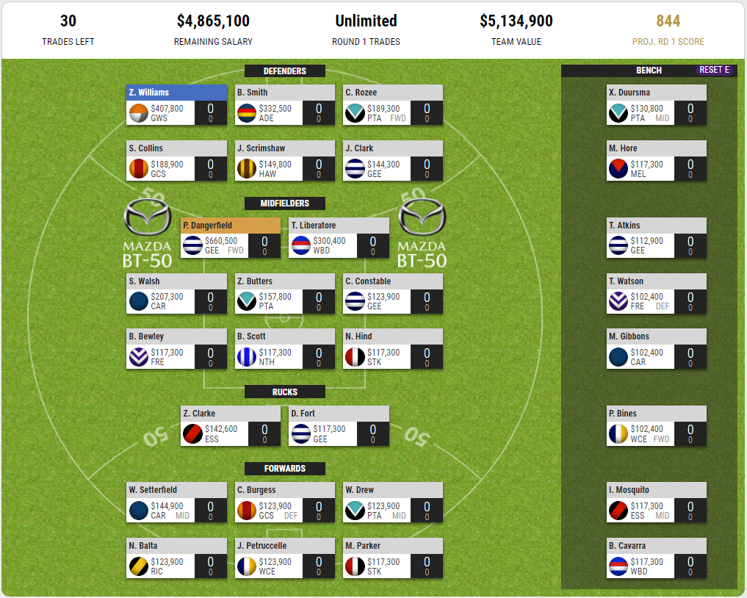

So in this last few days of preseason, although it might be scary, please keep in mind that as always it may be possible to do more with less. As a wise elder once said - “you have succeeded in life when all you really want is only what you really need“.

## How do I work this stuff out?

I have been asked by a number of readers how I am doing this type of analysis. As I have said in previous articles it is based on a field of mathematics called Combinatorial Optimisation or more specifically Mixed Integer Programming. There is definitely no pen, paper or hand calculators involved.

If I am able to formulate the problem in a certain way then there is very powerful computer software that can solve the problem for me. Using Monash University’s powerful computing infrastructure, MonARCH, the program takes between 2 to 3 hours to solve for the teams I used for the Optimal Team article and the Ghost Team article. To determine the team I used in this article, the computer took over 37 hours!

I also used Mixed Integer Programming to determine the Cookie Cutter teams, however the solver takes less than a second on my laptop as the problem is much smaller and has a nicer structure.

Australia is very strong in this area of mathematics. In the 1960s, [Alison Harcourt](https://www.abc.net.au/7.30/the-pioneering-mathematician,-still-inspiring/10353142?fbclid=IwAR3L9fP00kf_iPW7Amda-aI1SCGFk0GcHb2drLxeafTzOD0kKVTE0znZzE8) from Melbourne University proposed an algorithm design paradigm called Branch and Bound that is still at the heart of this field. Today, we have some of the world’s leading experts including Professors Andreas Ernst and Peter Stuckey at Monash University, and Professor Kate Smith-Miles at Melbourne University.